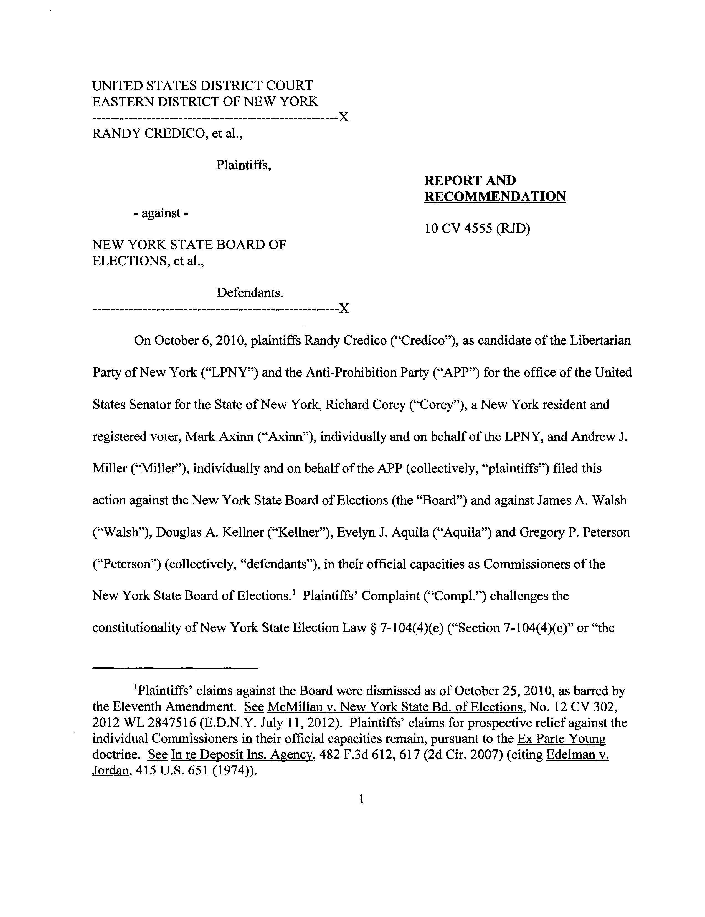Case 1:10-cv-04555-RJD-CLP Document 91 Filed 06/19/13 Page 1 of 45 PageID #: 798

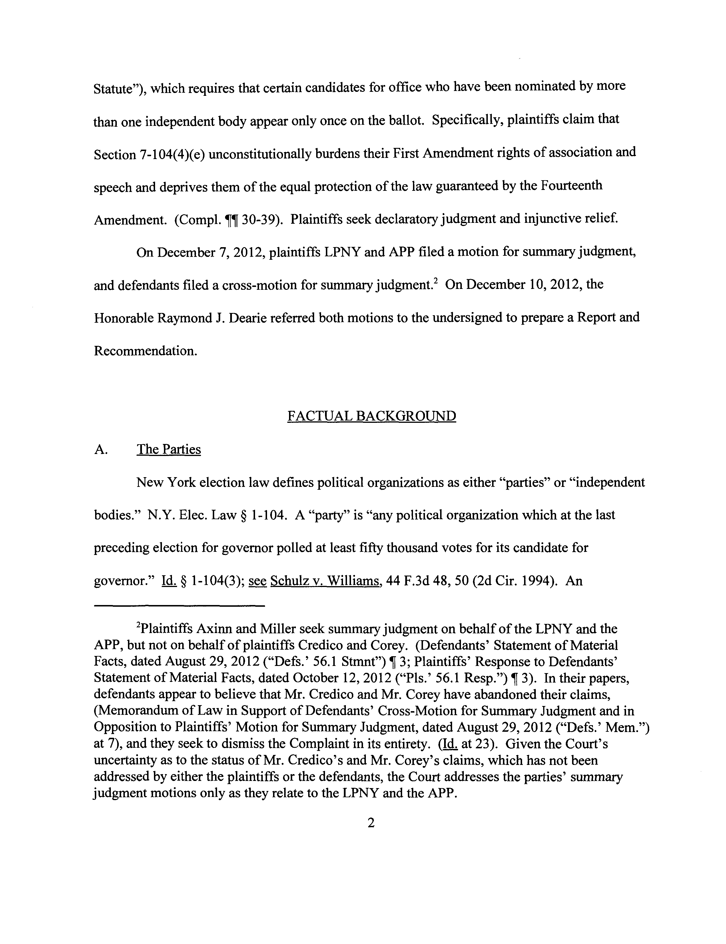Case 1:10-cv-04555-RJD-CLP Document 91 Filed 06/19/13 Page 2 of 45 PageID #: 799

